Lesson 03 XAS Resource Workbook

**Introduction to XANES**

**Charles A. Cardot and Gerald T. Seidler**

*All lessons and all versions can be found at* [*https://github.com/XASResourceWorkbook/XASResourceWorkbook*](https://github.com/XASResourceWorkbook/XASResourceWorkbook)

*This work is licensed under* ***CC BY-NC-SA 4.0***

**

Version History:

1.0 *Month Year*: C.A. Cardot, G.T. Seidler

Lesson 03 XAS Resource Workbook

**Introduction to XANES**

**Suggested Introductory Reading**

* Bunker (Chapters 4, 5.1, and 5.3) ISBN-13: 978-0521767750
* XAFS for EveryoneISBN-13: 978-1439878637 (Chapters 4 and 6)

**Overview and Advanced Reading**

<https://www.linkedin.com/pulse/100-years-xafs-papers-1-2-gerald-seidler/>

Cauchois & Mott, The interpretation of X-ray absorption spectra of solids <https://doi.org/10.1080/14786444908561417>

**We should include Robert Van Nostrand’s paper for the first measurement of the absorption coefficient of a catalyst, but I can’t find it for some reason.**

Various 80’s and 90’s studies on industry important 3d transition metal: Mn <https://doi.org/10.1016/0038-1098(80)90515-3>, Ti <https://www.osti.gov/biblio/5152935-synchrotron-radiation-xanes-spectroscopy-ti-minerals-effects-ti-bonding-distances-ti-valence-site-geometry-absorption-edge-structure> (need doi), and Fe <https://doi.org/10.1007/BF01204319>

**Should find first paper on fingerprinting technique.**

## **I. XANES fundamentals**

**Educational Goals**:

1. The XANES spectrum consists of the pre-edge, the rising edge (sometimes just known as “the edge”), and the ~50 eV region directly following the peak of the rising edge. Describe in general terms what is being probed by the XANES spectrum.

1. In terms of scattering, give a general description of how the XANES and EXAFS regions differ.
2. XANES has the potential to be sensitive to many physical characteristics, but this depends heavily on the system being observed. List a few of the characteristics that XANES has *the potential* to be sensitive to.

## **II. Oxidation:** The mechanics behind the connection between the XANES spectrum and oxidation are complex, but in general we can use the XANES to understand relative properties about oxidation states (see <https://doi.org/10.1016/s1386-1425(98)00153-x>).

**Educational Goals**:

1. To begin, what does it mean for an element to be oxidized?

1. Electrons in the core level of an atom are partially screened from the full effect of the nucleus by outer shell electrons. When oxidation occurs and the absorbing atom loses electrons, the core level experiences less screening. What do you expect to happen to the energy level of the core shells? (Hint: You can think about this in terms of the energy levels of Hydrogen-like atoms. If the screening changes, what happens to the effective nuclear charge?)
2. How will this affect the rising edge component of the XANES? How will this affect other features in the XANES (at higher energy than the rising edge)?
3. Below is a plot of the Mn K-edge for MnO, Mn2O3, and MnO2 which have formal oxidation numbers +2, +3, and +4 respectively. Do these follow the trend that you predicted in the previous problem? Explain.

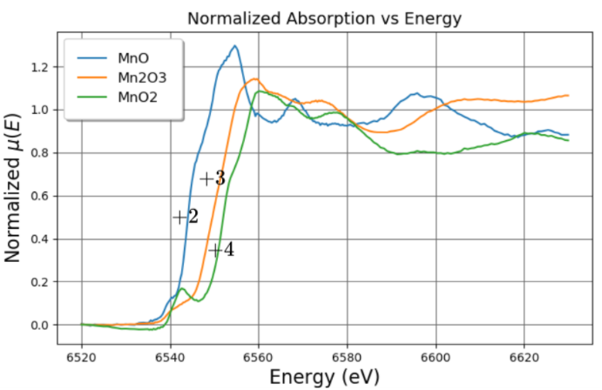

1. Formal oxidation number is not always the best measure of what is happening to the electron density in a molecule. The plot below gives the Cu K-edge for Cu, Cu2S, CuO, and CuS, which have formal oxidation numbers +0, +1, +2, and +2 respectively. In general, when can the simple oxidation rules be considered accurate?

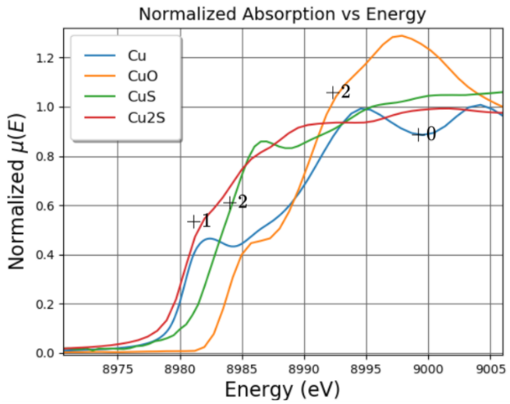

1. When electrons are removed from the valence shell of an absorbing atom, how does this affect the number of unoccupied states that the core electron can be excited into? How is this connected to oxidation state of the ion?
2. It is important to keep in mind that effects other than oxidation state are often at play, so it can be difficult to isolate the source of a trend within the XANES. Another important consideration is that when the photoelectron is excited out of the atom a core-hole is left behind. Does this have an effect on the density of states? Explain. How does this tie into the fact that XAS is fundamentally an excited state spectroscopy?

## **III. XANES Pre-edge**

**Educational Goals**:

1. For 3d transition metal K-edge XANES, pre-edge structures are often very weak (although not always) when compared to the rising edge. Why is this?
2. The figure below shows the unit cells for several different Vanadium oxides, together with their formulas (including the oxidation state of the metal ion). Which of these should be expected to have quite large pre-edge features from 3-d derived states and which should be expected to have only weak pre-edge?

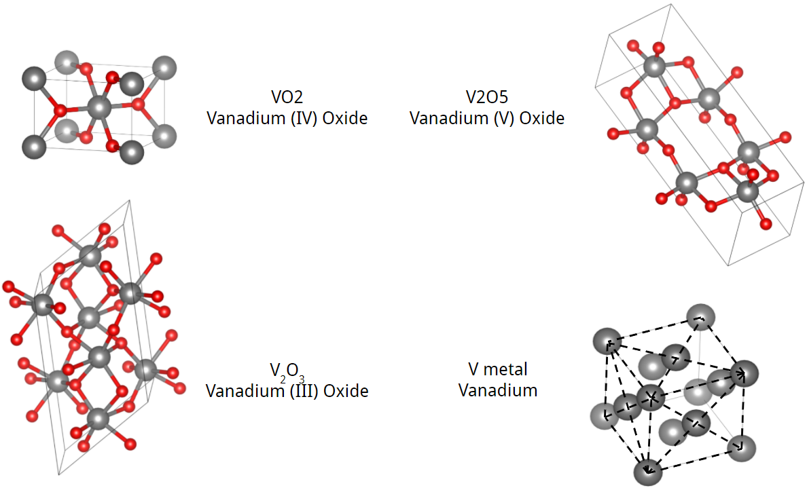

1. Consider the symmetry of the Vanadium atoms in each of the crystal structures from the previous problem. In general, how is the symmetry of the atoms around the Vanadium atom related to the behavior of the pre-edge?
2. Review the paper from ref [4]. What is it about the difference in the coordination geometry of Cr (III) and Cr(VI) that makes it easy to detect Cr(VI)? What change does it cause in the absorption spectrum? Why is detecting the Cr(VI) concentration so important?
3. Below are the XANES spectra for 3 compounds [3]. In all three, Fe has the same formal oxidation state of +1. How is the position of the pre-edge is connected to the electronegativity of the atoms which Fe is bonded to? Explain.

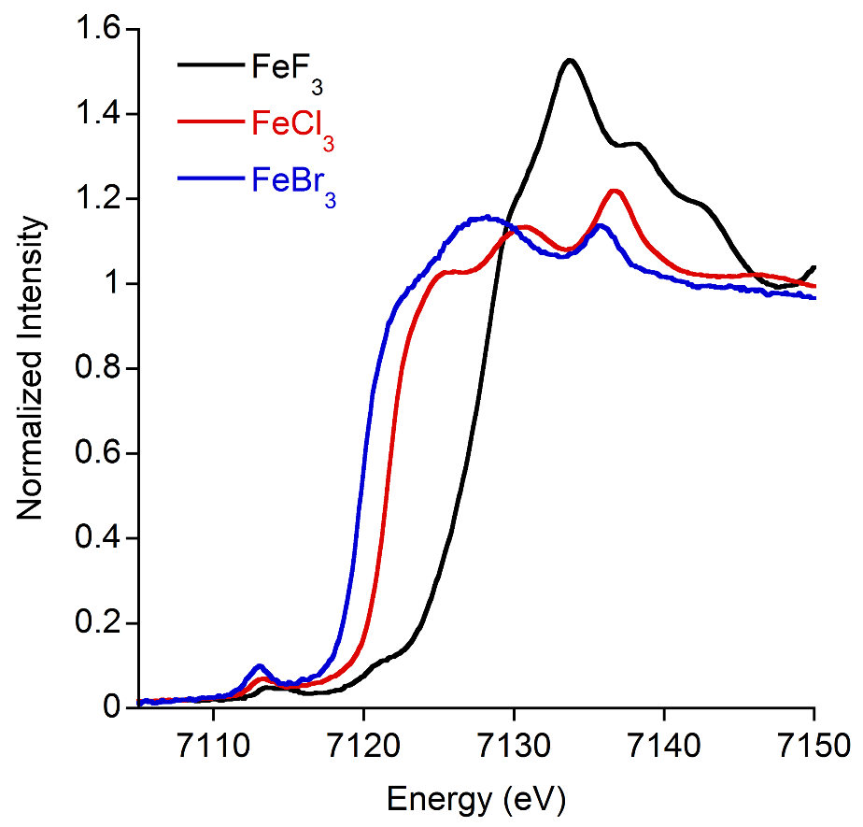

1. So far, we have almost exclusively discussed crystalline materials, but XAFS is applicable to all kinds of materials and systems. Consider a typical 3d metal ion in solution. How would the XANES and the EXAFS differ for an octahedral coordination vs a tetrahedral coordination?